Evolving (Intelligent) systems

Online incremental machine learning adapt their parameters online while evolving systems adapt also their structure in a single-pass manner [3] and in real time [43].
The focus of fuzzy rule-based (FRB) evolving systems (ES) is precise (Takagi-Sugeno-Kang) fuzzy modeling (classification, approximation) and linguistic (Zadeh-Mamdani) fuzzy modeling.
Each local sub model is defined by clusters or fuzzy sets and locally linear models.
The system is ideally built from scratch without any initial data (user defined fuzzy partitioning, or number of classes).
Expert knowledge [12]:
- Constraints
- Selection of fuzzy set
- Specific learning schemes and parameters
- Post processing

The environment is unknown. Rule-based fuzzy, interval, and granular models are more transparent and linguistically explainable compared to other black-box universal approximators like neural networks. [10]
Information granules [9,11], rules, trees [16, 42], neurons [10]
Monographs:
- Evolving Connectionist Systems (2007)
- Evolving Intelligent System – Methodology and Applications (2010)
- Evolving Fuzzy Systems Methodologies, Advanced Concepts and Applications (2011) [40]

Data stream

[25,26,27,28,29]
- the data samples arrive online one at a time,
- the data are generated as long as the process is active and are not limited in quantity,
- samples are/should be discarded immediately after processing
- data characteristics are time-varying with nonstationary concept shifts and drifts phenomena
- processing time should scale efficiently with data size and number of model parameters

industry, telemetry, traffic, e-commerce, internet of things, [31]

modeling, identification, inference, control, prediction, clustering, classification, fault detection, anomaly detection, frequent pattern mining, image recognition [8], decision support, soft sensor [12], self-calibrating sensors, high frequency trading [45], data mining, artificial intelligence, cyber security [31], medical prognostics,

Only one scan of a Big Data data base is possible.
Stability-plasticity dilemma. Stability refers to the long-term solution convergence and Plasticity to the dynamic concept change handling [12, 49]

Fuzzy and neuro-fuzzy

Evolving methods can be divided into different categories according to their structure, ability of learning, level of autonomous adapting [39]

Type I and type II fuzzy sets. Type 2 fuzzy sets hold information about the uncertainty of membership. This representation is usually approximated with prediction intervals as it is easier to calculate.

Takagi-Sugeno-Kang
- fuzzy: Evolving Takagi-Sugeno (eTS) [3]
- Neuro-fuzzy: EFuNN, dynamic evolving neural-fuzzy inference system (DENFIS) [4]
Takagi-Sugeno-Kang membership function are data clusters with Gaussian distribution.

Neuro-fuzzy use neurons as structural components and a network topology. They can be equivalently described with fuzzy rules.
Local model network (LMN)

Clustering and Granulation

Generally in fuzzy rule based (FRB) systems a rule can have more than one cluster/granule/cloud [41], but having one cluster for one rule simplifies the merging, splitting, removal of rules. Although this increases the level of granularity.
The evolving system antecedent can be realized by information granules [9,11], leaves [16], neurons, data clouds [41], clusters [9], hyperplanes [16], (Voronoi) tessellations [45]. Although membership function can differ significantly from the real data distribution [45].
The membership functions are usually pre-defined based on the assumed data distribution, i.e., Gaussian, trapezoidal, or triangular fuzzy sets or clusters. Usually, the output defuzzification for linguistic models is done by a center-of-gravity calculation, for functional TSK a fuzzily weighted average is calculated, and for classification a winner-takes-all approach is used [41].

Subtractive Clustering (mountain clustering) [3, 46], Fuzzy C-means, recursive Gustafson–Kessel [3,13], recursive Gath-Geva [14], evolving clustering method (EMC) [4], incremental fuzzy C-regression clustering [31], eClustering [46], possibilistic clustering, density-based [39, 41], scatter-based [8], vector quantization [49]

evolving clustering method [4]
incremental fuzzy C-regression clustering [31]
The parameters of the consequent part are the prototypes used in clustering

Hyperplane parameters can be shared between in the premise and consequent part of the locally linear models.
Intervals
Granules are groups of objects or elements with common properties [41] that are similar in functionality or proximity [11]. Some granulations are represented as clouds and do not use boundaries or centers but compute the membership functions based on accumulated data [41].

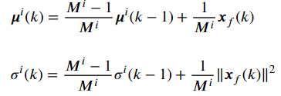
Egauss [43]
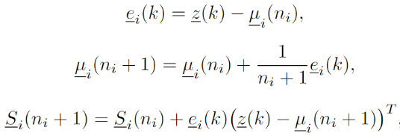
Vector quantization [49]
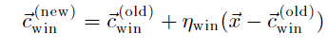
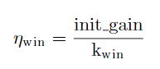
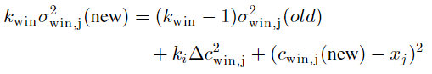

Adding clusters

Transparency and interpretability [12]:
- Distinguishability of system components (non-overlapping, non-redundant),
- simplicity (complexity reduction, complexity-accuracy tradeoff, merging),
- consistency (overlapping antecedent clusters with dissimilar consequent parameters),
- coverage and completeness (shifts and drifts),
- feature importance levels,
- rule importance levels
- interpretation of consequents.
- knowledge expansion

usually based on a threshold of:
- Model output error,
- distance of sample to existing cluster centers (Euclidean, Mahalanobis) [49]
- membership degree to existing clusters, minimal coverage (є-completeness)
- sample potential [3]
- sample density [39]
- maximum allowed number of clusters [39]

Closseness [39]
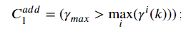
Number of samples after the closeness criterion [39]
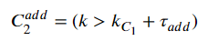
Number of samples after the last added cluster [39]
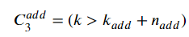
The number of clusters [39]
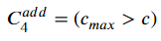
Typicality [43]
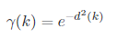
Multimodal Continuous Typicality [45]
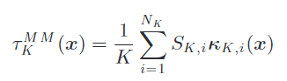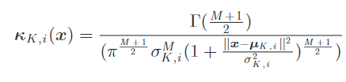
Chebyshev inequality [45] describes the probability of a particular data sample to be n standard deviations away from the mean
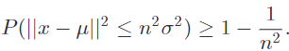
The new local models are added based on an average of existing clusters [45] or set to default values (zero).
A notable problem is the detection of nonlinearities and prevention of adding clusters based on outliers. [39]

Cluster Merging
Sample arrive at random and can create too many clusters. Rule merging is not the same as fuzzy set merging [12] as multiple fuzzy sets can be associated with a rule depending on the formulation. as Ellipsoid in arbitrary positions are a generalized fuzzy systems with multivariate Gaussian functions as granules.
Cluster merging and splitting can be used to compensate a bad selection of hyperparameters [49].
cluster fusion or coalescence when clusters drift together due to new data filling space between data clouds, cluster delamination when clusters drift apart [6]

Overlapping and volumetric similarity [5,6] (Kullback–Leibler divergence, Bhattacharyya distance [6])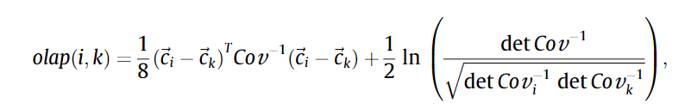
Correlation between cluster activations [5]
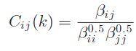
Distance of cluster centers [17]
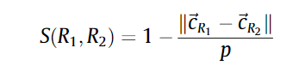
Distance condition [5,14]
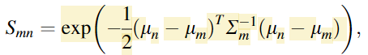
distance-ratio condition [5]
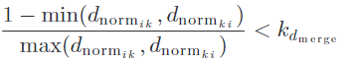
Parameter angles condition [5]
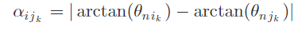
Model transfer function frequency response [19]
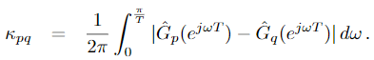
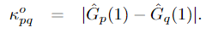
geometric-based similarity measure (Jaccard index) [18] for fuzzy set merging
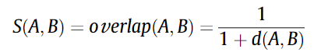
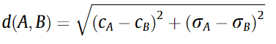
Kernel-based similarity measure with the Welch test [20] for fuzzy set merging
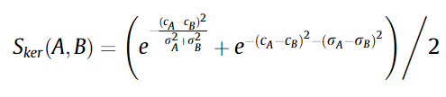
Local and global density of samples [39]
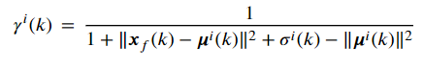
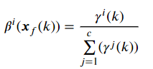

How to merge

fuzzy sets [20]
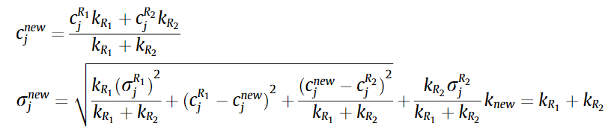
Unidimensional Fuzzy sets [21]
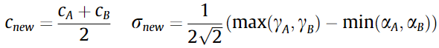
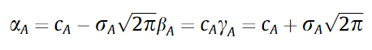

Ellipsoid Gaussian clusters [19, 43]
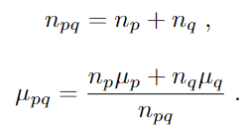
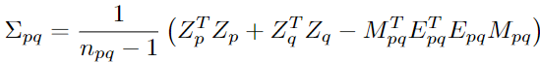
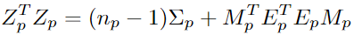

[5]
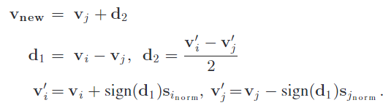
Margina clouds as soon as they are formed [45]
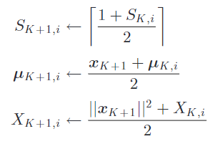
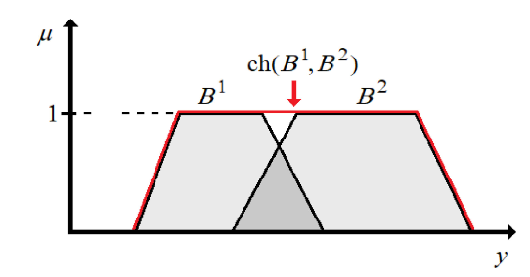

Cluster splitting
Possible partition errors
- Innapropriate merging criterion
- Concept shifts and drifts in the data stream
- finer partitioning desired
Distances to hyperplanes [16]

Cherkoff

Fidelity measure

Bayesian information criterion [6]
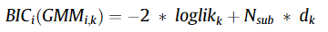
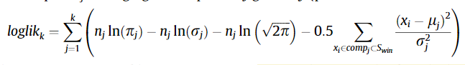
Welch test (a version of the t-test), a measure of cluster distance [6]
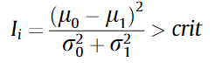
Relative model error [5]
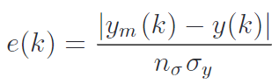

Cluster removal
Clusters can be removed to increase accuracy or to simplify the model structure (for efficiency or to reduce complexity), the model changes because of concept shifts, the model is wrong because of outliers or bad parameters.
Although the adding mechanism should not add clusters based on outlier data, this can still happen [53]. Therefore, a mechanism is required to mitigate past mistakes. Note that unbalanced data from rare/cyclical/periodic events are in contradiction with outliers. These event are disproportionally represented in the data, but have a lot of information. Cluster removal must be done carefully because we do not want to remove clusters that have useful information [39]. The is still no reliable solution to this problem.

The number of samples belonging to the removed cluster in a time interval are bellow a threshold. [5], the cluster was inactive for a number or steps [11].

Overlap, similarity [12], age (old clusters) [41], utility (relative membership activation, rarely utilized, irrelevant) [22,41,45], minimal activation (support, є-completeness).
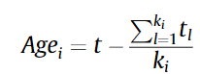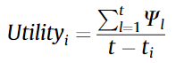
Relative number of samples in cloud (activity) [39] [5] and relative number of samples least from a cloud.
Informativeness [39]
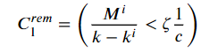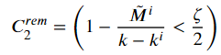

Parameter optimization
Global method and local method [15]. In the global method, all local linear models are optimized together, while in the local method the parameters of the models are optimized separately. of the Local optimization is preferred, as the resulting locally linear models become more interpretable and standalone. Global methods usually result in higher accuracy of the complete model output, but the locally linear models are not interpretable on their own and the overall model is more unstable.

Recursive weighted least squares [40] or fuzzy weighted recursive least squares [45]
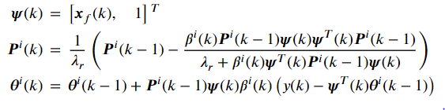
fuzzy weighted generalized RLS method
Recursive Levenberg–Marquardt
Multi-innovation – taking in consideration multiple past error values to achieve better convergence in case of structural changes [47]
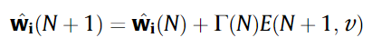
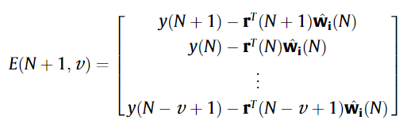
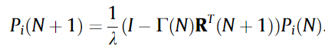

auxiliary model – Replacing an unmeasurable variable (like the noise) in the regressor/information matrix by using an estimation of the variable instead of the real value.
Hierhical principle – decomposes the system into multiple where multiple regressors are used in every optimization. ( used to identify multivariable systems or noise transfer functions).
Combining both approaches an unknown variable can be optimized in one optimization, used to estimate another regression variable and finally used in another optimization.
instrumental variables – the output of the system is replaced by the model prediction (both are present)
Correntropy - a Mercer's kernel (usually Gaussian) of the error values in the optimization criteria function used to lower the effect of outlier samples [47].
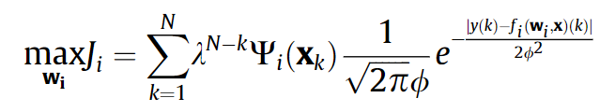
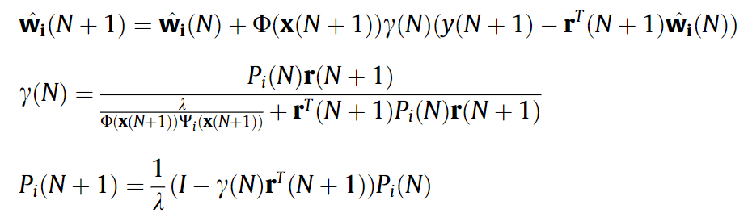
Stochastic gradient

Kalman filter

Lughofer, E. (2021). Improving the robustness of recursive consequent parameters learning in evolving neuro-fuzzy systems. Information Sciences, 545, 555–574. https://doi.org/10.1016/J.INS.2020.09.026

Ensamble learning

Ensembles of multiple different models (experts) are trained in parallel and combined to improve accuracy and robustness [10, 48] or combine multiple evolving systems in a deep network structure as building blocks [44] to achieve higher complexity. The first use different structure (number of rules or different operators), parameter, constraints, objective functions, or different evolving systems altogether.

For the tasks of processing images, videos, texts, and speeches a deep architecture is required. But deep neural networks usually suffer from a lack of interpretability and cannot handle streaming data [44].

MEEFIS (2019) [44] multilayer ensemble evolving fuzzy inference system
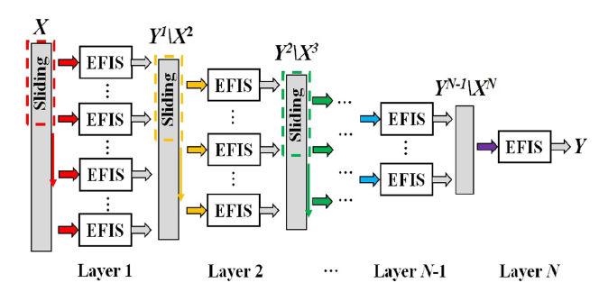
Extreme Learning Machines (ELMs) (2009) (randomly initialized parameters and structure)
eClass (2014) convex envelope
Autonomous Learning Multiple Model (ALMMo)
Parsimonious ensemble (pENsemble) (2018) (with model removal and feature selection)
Ensamble of Fuzzy-set-Based evolving Models (FBeM)[53] (2015) (different structures and parameters)
Ensamble of optimal evolving granular experts (eOGS) (2019) [48]

Evolving fuzzy control systems

RECCO [34]
[35],[36],[37],[38]

Potential future work

- Big data, Internet of Things (IoT), eXplainable Artificial Intelligence (XAI), Cyber-Physical Systems (CPS), Smart Industry (SmI) [10], soft sensors/eSensors [12]

- Regressor selection, Propositions, lemmas, theorems, missing data, outliers, design of experiments, workflows, performance metrics, parallelization [10]

Seznam modelov

Gaussian ARTMAP (1996)[2]
fuzzy
eTS (2004)[3] evolving Takagi-Sugeno
exTS (2006) and eTS+ (2010) extended Takagi-Sugeno
FLEXFIS (2008)[49] and FLEXFIS+ (2011), FLEXible Fuzzy Inference System
eFuMo (2015) [5] Evolving Fuzzy Model
eOGS (2019) [7] - evolving Optimal Granular System
GS-EFS (2015) Generalized Smart Evolving Fuzzy System
IBeM (2010) Interval-Based evolving Modeling
FBeM (2012) Fuzzy-set-Based evolving Modeling
SAFIS (2006 [22], 2011 [23]) Sequential Adaptive Fuzzy Inference System
MSAFIS (2017) Modified Sequential Adaptive Fuzzy Inference System
eClass (2008) Evolving Classifiers
AutoClassify (2012)
Neuro-fuzzy
Neuro Gas (1994) [1]
EFuNN (1998, 2007) Evolving Fuzzy Neural Network
DENFIS (2002)[4] Dynamic Evolving Neuro-Fuzzy Inference System
SOFNN (2004) Self-Organizing Fuzzy Neural Networks
Elipsoidal Gaussian functions

GANFIS (2003) [24] Generalized Adaptive Neuro-Fuzzy Inference Systems
eGNN (2013) evolving Granular Neural Network
hyper-rectangles and trapezoidal membership functions
D-FNN (2000) Dynamic Fuzzy Neural Network
GD-FNN (2001) Generalized Dynamic Fuzzy Neural Network
Elipsoidal Gaussian functions
NeuCube (2014) Neural Cube
NeuroFAST (2001) online neuro-fuzzy ART-based model
ESOM (2000, 2007) Evolving Self-Organizing Map
SOFMLS (2009) Self-Organizing Fuzzy Modified Least Square network
ENFM (2010)[14] Gath-Geva Evolving Neuro-Fuzzy Modeling
PANFIS (2014) PArsimonious Network based on Fuzzy Inference System
RIVMcS-FNN (2015) Recurrent Interval-Valued Metacognitive Scaffolding Fuzzy Neural Network
ALMMo (2018)[45] Autonomous Learning Multiple Model

Ne vem
EFP
ePL
GENFIS/GENEFIS (2013) Generic Evolving Neuro-Fuzzy Inference System
eT2FIS (2013) evolving Type-2 neural fuzzy inference system
IRSFNN (2013) interactively recurrent self-evolving fuzzy neural network
rGK (2011)[13] recursive Gustafson-Kessel
SONFIN(1998)
Granules
eGNN Evolving Granular Neural Networks (2012)
ENFIS
Trees
eFLRT Evolving fuzzy linear regression tree

[1] Fritzke, B. (1994). Growing cell structures – A self-organizing network for unsupervised and supervised learning. Neural Networks, 7(9), 1441–1460.
[2] Williamson, J. R. (1996). Gaussian ARTMAP: A Neural Network for Fast Incremental Learning of Noisy Multidimensional Maps. Neural Networks : The Official Journal of the International Neural Network Society, 9(5), 881–897.
[3] Angelov, P. P., & Filev, D. P. (2004). An Approach to Online Identification of Takagi-Sugeno Fuzzy Models. IEEE Transactions on Systems, Man, and Cybernetics, Part B: Cybernetics, 34(1), 484–498.
[4] Kasabov, N. K., & Song, Q. (2002). DENFIS: Dynamic evolving neural-fuzzy inference system and its application for time-series prediction. IEEE Transactions on Fuzzy Systems, 10(2), 144–154.

[5] Dovžan, D., Logar, V., & Škrjanc, I. (2015). Implementation of an Evolving Fuzzy Model (eFuMo) in a Monitoring System for a Waste-Water Treatment Process. IEEE Transactions on Fuzzy Systems, 23(5), 1761–1776.
[6] Lughofer, E., & Sayed-Mouchaweh, M. (2015). Autonomous data stream clustering implementing split-and-merge concepts – Towards a plug-and-play approach. Information Sciences, 304, 54–79.
[7] Leite, D., Andonovski, G., Skrjanc, I., & Gomide, F. (2020). Optimal rule-based granular systems from data streams. IEEE Transactions on Fuzzy Systems, 28(3), 583–596.
[8] D. Leite, I. Škrjanc, and F. Gomide, “An overview on evolving systems and learning from stream data,” Evolving Systems, vol. 11, no. 2, pp. 181–198, Jun. 2020.
[9] Porto, A., & Gomide, F. (2022). Evolving hyperbox fuzzy modeling. Evolving Systems, 1, 1–12.
[10] Leite, D., Škrjanc, I., & Gomide, F. (2020). An overview on evolving systems and learning from stream data. Evolving Systems, 11(2), 181–198.
[11] Leite, D., Costa, P., & Gomide, F. (2010). Granular Approach for Evolving System Modeling. Lecture Notes in Computer Science (Including Subseries Lecture Notes in Artificial Intelligence and Lecture Notes in Bioinformatics), 6178 LNAI, 340–349.
[12] Lughofer, E. (2013). On-line assurance of interpretability criteria in evolving fuzzy systems – Achievements, new concepts and open issues. Information Sciences, 251, 22–46.
[13] Dovžan, D., & Škrjanc, I. (2011). Recursive clustering based on a Gustafson-Kessel algorithm. Evolving Systems, 2(1), 15–24.
[14] Soleimani-B, H., Lucas, C., & Araabi, B. N. (2010). Recursive Gath-Geva clustering as a basis for evolving neuro-fuzzy modeling. Evolving Systems, 1(1), 59–71.
[15] Nelles, O. (2001). Nonlinear System Identification. Nonlinear System Identification.
[16] Dovzan, D., & Skrjanc, I. (2020). Fuzzy Space Partitioning Based on Hyperplanes Defined by Eigenvectors for Takagi-Sugeno Fuzzy Model Identification. IEEE Transactions on Industrial Electronics, 67(6), 5144–5153.
[17] E. Lima, M. Hell, R. Ballini, F. Gomide, Evolving fuzzy modeling using participatory learning, in: P. Angelov, D. Filev, N. Kasabov (Eds.), EvolvingIntelligent Systems: Methodology and Applications, John Wiley & Sons, New York, 2010, pp. 67–86.
[18] J.V. Ramos, C. Pereira, A. Dourado, The building of interpretable systems in real-time, in: P. Angelov, D. Filev, N. Kasabov (Eds.), Evolving IntelligentSystems: Methodology and Applications, John Wiley & Sons, New York, 2010, pp. 127–150
[19] Andonovski, G., Lughofer, E., & Skrjanc, I. (2021). Evolving Fuzzy Model Identification of Nonlinear Wiener-Hammerstein Processes. IEEE Access, 9, 158470–158480.

[20] Lughofer, E., Bouchot, J. L., & Shaker, A. (2011). On-line elimination of local redundancies in evolving fuzzy systems. Evolving Systems, 2(3), 165–187.
[21] G. Leng, X.-J. Zeng, J.A. Keane, An improved approach of self-organising fuzzy neural network based on similarity measures, Evolving Systems 3 (1)(2012) 19–30
[22] Rong, H. J., Sundararajan, N., Huang, G. bin, & Saratchandran, P. (2006). Sequential Adaptive Fuzzy Inference System (SAFIS) for nonlinear system identification and prediction. Fuzzy Sets and Systems, 157(9), 1260–1275.
[23] H.-J. Rong, N. Sundararajan, G.-B. Huang, G.-S. Zhao, Extended sequential adaptive fuzzy inference system for classification problems, EvolvingSystems 2 (2) (2011) 71–82.
[24] Azeem, M. F., Hanmandlu, M., & Ahmad, N. (2003). Structure Identification of Generalized Adaptive Neuro-Fuzzy Inference Systems. IEEE Transactions on Fuzzy Systems, 11(5), 666–681.
[25] J. Gama, Knowledge Discovery from Data Streams, 1st ed. Chapman
& Hall/CRC, 2010.
[26] E. Lughofer, “Improving the robustness of recursive consequent param-
eters learning in evolving neuro-fuzzy systems,” Information Sciences,
vol. 545, pp. 555–574, 2 2021
[27] I. Škrjanc, J. Iglesias, A. Sanchis, D. Leite, E. Lughofer, and F. Gomide,
“Evolving fuzzy and neuro-fuzzy approaches in clustering, regression,
identification, and classification: A survey,” Information Sciences, vol.
490, pp. 344–368, 7 2019
[28] D. Ge and X. J. Zeng, “A self-evolving fuzzy system which learns
dynamic threshold parameter by itself,” IEEE Transactions on Fuzzy
Systems, vol. 27, pp. 1625–1637, 8 2019
[29] C. Garcia, A. Esmin, D. Leite, and I. ˇSkrjanc, “Evolvable fuzzy systems
from data streams with missing values: With application to temporal
pattern recognition and cryptocurrency prediction,” Pattern Recognition
Letters, vol. 128, pp. 278–282, 12 2019.
[30] D. Leite, G. Andonovski, I. Skrjanc, and F. Gomide, “Optimal rule-
based granular systems from data streams,” IEEE Transactions on Fuzzy
Systems, vol. 28, pp. 583–596, 3 2020
[31] Blazic, S., & Skrjanc, I. (2020). Hybrid system identification by incremental fuzzy C-regression clustering. IEEE International Conference on Fuzzy Systems, 2020-July.

[32] P. Angelov and X. Zhou, “Evolving fuzzy systems from data streams inreal-time,” in 2006 International Symposium on Evolving Fuzzy Systems,Lake District, UK, IEEE Press, pp.29-35, 2006, pp. 7–9
[33] P. Angelov,Evolving Takagi-Sugeno Fuzzy Systems from Streaming Data(eTS+). John Wiley & Sons, Ltd, 2010, ch. 2, pp. 21–50
[34] G. Andonovski, P. P. Angelov, S. Blažič, and I. Škrjanc, “Robust evolving cloud-based controller (recco),” in2017 Evolving and AdaptiveIntelligent Systems, EAIS 2017, Ljubljana, Slovenia, May 31 - June 2,2017, I.Škrjanc and S. Blažič, Eds. IEEE, 2017, pp. 1–6
[35] G. Andonovski, B. S. J. Costa, S. Blažič, and I.Škrjanc, “Robust evolving controller for simulated surge tank and for real two-tank plant,”Automatisierungstechnik, vol. 66, no. 9, pp. 725–734, 2018.
[36] R. Precup, M. Tomescu, S. Preitl, E. M. Petriu, J. C. Fodor, andC. Pozna, “Stability analysis and design of a class of MIMO fuzzycontrol systems,”J. Intell. Fuzzy Syst., vol. 25, no. 1, pp. 145–155,2013.
[37] K. Mls, R. Cimler, J. Vasc ́ak, and M. Puheim, “Interactive evolutionaryoptimization of fuzzy cognitive maps,”Neurocomputing, vol. 232, pp.58–68, 2017
[38] R. Precup and M. Tomescu, “Stable fuzzy logic control of a general class of chaotic systems, ”Neural Computing and Applications, vol. 26,no. 3, pp. 541–550, 2015.
[39] Andonovski, G., Mušič, G., Blažič, S., & Škrjanc, I. (2018). Evolving model identification for process monitoring and prediction of non-linear systems. Engineering Applications of Artificial Intelligence, 68, 214–221.

[40] Lughofer, E., 2011. Evolving fuzzy systems Methodologies, advanced oncepts and appli-cations, first ed. Springer-Verlag, Berlin Heidelberg, p. 480.
[41] Angelov, P., & Yager, R. (2011). Simplified fuzzy rule-based systems using non-parametric antecedents and relative data density. IEEE SSCI 2011: Symposium Series on Computational Intelligence - EAIS 2011: 2011 IEEE Workshop on Evolving and Adaptive Intelligent Systems, 62–69.
[42] Lemos, A., Caminhas, W., & Gomide, F. (2010). Evolving fuzzy linear regression trees. 2010 IEEE World Congress on Computational Intelligence, WCCI 2010.

[43] Skrjanc, I. (2020). Cluster-Volume-Based Merging Approach for Incrementally Evolving Fuzzy Gaussian Clustering-eGAUSS+. IEEE Transactions on Fuzzy Systems, 28(9), 2222–2231.

[44] Gu, X. (2021). Multilayer Ensemble Evolving Fuzzy Inference System. IEEE Transactions on Fuzzy Systems, 29(8), 2425–2431.

[45] Angelov, P. P., Gu, X., & Principe, J. C. (2018). Autonomous learning multimodel systems from data streams. IEEE Transactions on Fuzzy Systems, 26(4), 2213–2224.
[46] Angelov, P., & Yager, R. (2012). A new type of simplified fuzzy rule-based system. International Journal of General Systems, 41(2), 163–185.
[47] Lughofer, E. (2021). Improving the robustness of recursive consequent parameters learning in evolving neuro-fuzzy systems. Information Sciences, 545, 555–574.

[48] Leite, D., & Škrjanc, I. (2019). Ensemble of evolving optimal granular experts, OWA aggregation, and time series prediction. Information Sciences, 504, 95–112.
[49] Lughofer, E. D. (2008). FLEXFIS: A robust incremental learning approach for evolving Takagi-Sugeno fuzzy models. IEEE Transactions on Fuzzy Systems, 16(6), 1393–1410.

[50] Huang, G. bin, Saratchandran, P., & Sundararajan, N. (2004). An efficient sequential learning algorithm for growing and pruning RBF (GAP-RBF) networks. IEEE Transactions on Systems, Man, and Cybernetics, Part B: Cybernetics, 34(6), 2284–2292.

[51] Garcia, C., Leite, D., & Skrjanc, I. (2020). Incremental Missing-Data Imputation for Evolving Fuzzy Granular Prediction. IEEE Transactions on Fuzzy Systems, 28(10), 2348–2362.
[52] Lughofer, E. (2012). A dynamic split-and-merge approach for evolving cluster models. Evolving Systems, 3(3), 135–151.

[53] Lughofer, E. (2008). Extensions of vector quantization for incremental clustering. Pattern Recognition, 41(3), 995–1011.

[54] Leite, D., Ballini, R., Costa, P., & Gomide, F. (2012). Evolving fuzzy granular modeling from nonstationary fuzzy data streams. Evolving Systems, 3(2), 65–79.

[55] Bao, R. J., Rong, H. J., Angelov, P. P., Chen, B., & Wong, P. K. (2018). Correntropy-Based Evolving Fuzzy Neural System. IEEE Transactions on Fuzzy Systems, 26(3), 1324–1338.

[56] Pratama, M., Anavatti, S. G., & Lughofer, E. (2014). Genefis: Toward an effective localist network. IEEE Transactions on Fuzzy Systems, 22(3), 547–562.

Design of experiment

